William Wright

Lab 5

(1) UDP servers go through five (5) basic steps. What are those steps (including the associated function calls (e.g., someFunction() )?

Create the socket socket();

Bind the socket to bind();

On the server, wait for a message recvfrom();

Send a response back to the client sendto();

Close the socket close();

(2) UDP clients go through five (5) basic steps. What are those steps (including the associated function calls (e.g., someFunction() )?

Create the socket socket();

send a message sendto();

Waint for a response from the server

process response form the server recevfrom();

Close the socket close();

With the last part of the discussion we used a connect() instead

(3) How would that change the UDP client steps? Also include function calls?

In udp you don’t have to send a connect due to the nature of udp so the steps would look this this

Create the socket socket();

Send the connect connect();

send a message sendto();

Wait for a response from the server

process response form the server recevfrom();

Close the socket close();

(4) What is the problem with the code?

You are dividing by 0

(5) What is the signal received

Thread 1: EXC_ARITHMETIC (code=EXC_I386_DIV, subcode=0x0)

(6) How could you fix this code?

First thing to do its make cnt =1 from the start, then in your while (cnt <=10) set it less then or equal to, then change out to = val[cnt-1]; and change the last number in your array from 0. ß

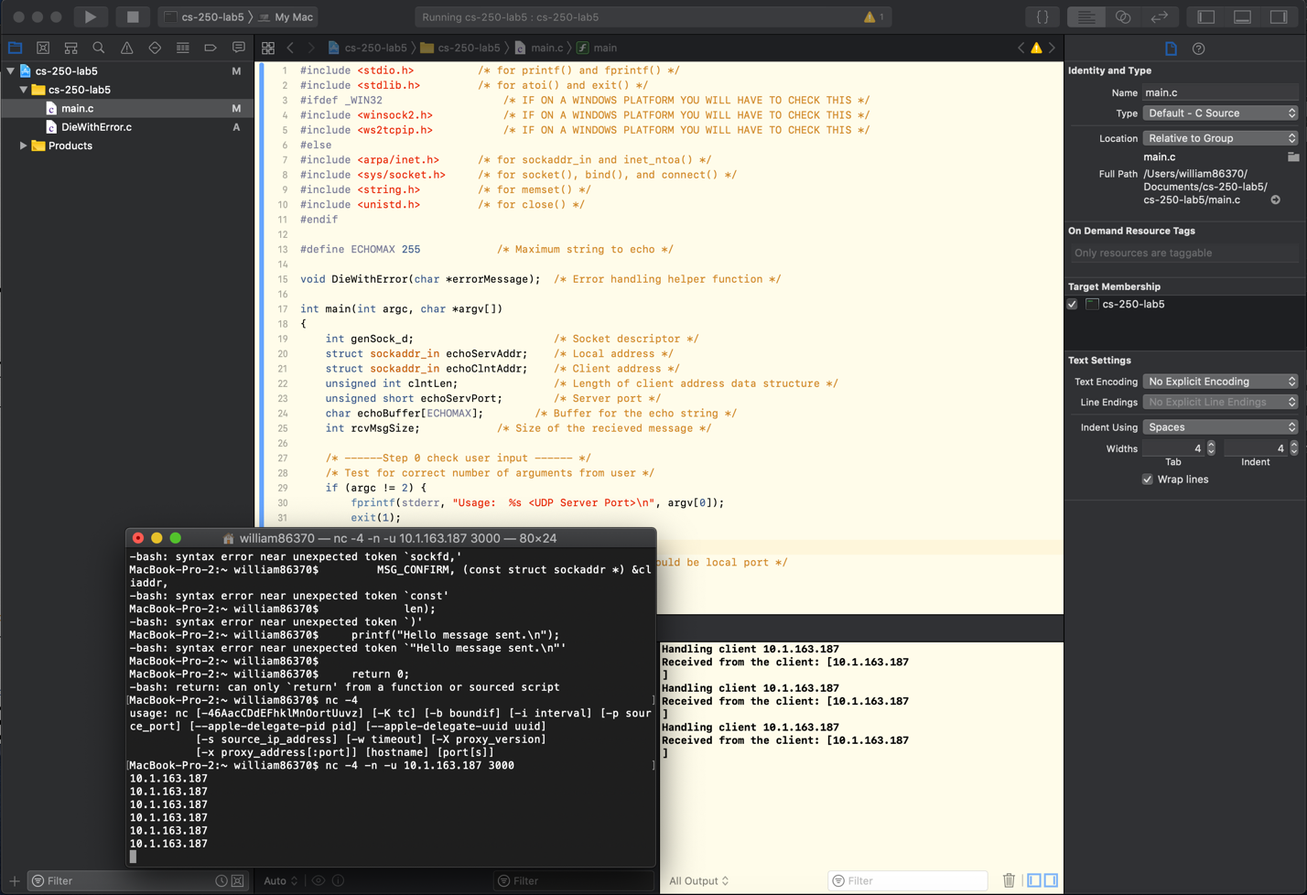

Here you can see the server running in xcode and my command line running the connection command I didn’t have anything else on my clipboard but my ip address so I pasted that 3 times to make sure it sent and returned it .

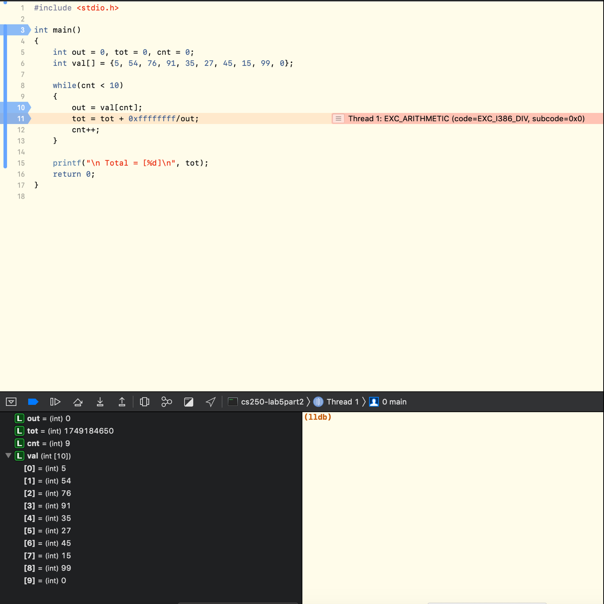

xcode has built in gdb functionality so I decided to use this instead of the command line way.

This made it easy for me to see what is running and I can add breakpoints in multiple places. In the bottom left you can see the values of each object at the time of the break.